Hybrid NLP and Ensemble Machine Learning Browser Extension for Claim-Level Misinformation Detection and Evidence-Based Verification in Online Health Information
Chrome Extension • Hybrid NLP/ML • Evidence Verification • Adaptive Learning

1. Project Overview
The proposed system is a browser-based health misinformation detection and verification tool. Instead of classifying an entire post as simply real or fake, the system identifies health-related, verifiable claims, analyzes them using machine learning, retrieves relevant trusted evidence, and compares the claim with that evidence before presenting an explainable result to the user.
The Chrome extension serves as the user-facing layer. The ML classifier provides a pattern-based prediction, while the evidence subsystem provides an evidence-based second assessment. These two results are interpreted by a decision layer rather than being treated as identical sources of truth.

2. Agreed High-Level Architecture
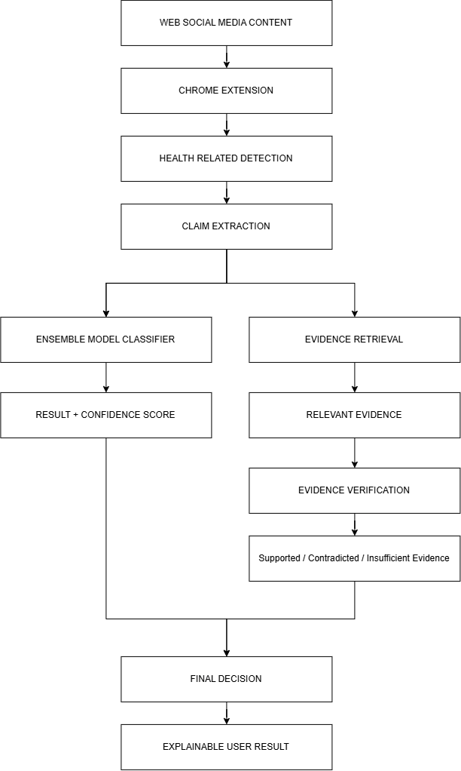

3. Processing Flow
Content Capture: The Chrome extension reads supported page content or the portion selected for analysis.
Health-Domain Detection: The system determines whether the content is within the health domain. Non-health content is marked outside the system scope.
Verifiable Claim Detection: The system determines whether the text contains a factual statement that can be checked. Opinions, questions, and purely subjective statements should not be forced into a true/false result.
Claim Extraction: The exact factual assertion is isolated from surrounding opinions, recommendations, or unrelated text.
ML Classification: The trained classifier predicts whether the claim resembles reliable information or misinformation and returns an appropriate model confidence score.
Evidence Retrieval: The system searches a maintained evidence repository for passages that are semantically relevant to the extracted claim.
Evidence Verification: The retrieved evidence is compared with the claim to determine whether it supports the claim, contradicts it, or is insufficient to establish either conclusion.
Decision & Explanation: The system presents the ML result, evidence result, agreement/conflict state, and supporting references in the extension.

4. Machine Learning Classifier
The classifier is trained on a labeled health misinformation dataset. Its role is prediction based on patterns learned during training; it is not the evidence repository and does not search for a matching database row during normal use.

Possible Model Strategy
The existing concept may retain an ensemble such as Linear SVM, Naive Bayes, and a transformer model (for example, RoBERTa). Traditional models provide useful baselines, while the transformer contributes context-sensitive language representations. Final model selection and ensemble weighting should be based on validation performance rather than arbitrary weights.
Recommended evaluation: Accuracy, Precision, Recall, F1-score, confusion matrix, and per-class performance.

5. Evidence Retrieval and Verification
Evidence retrieval is separate from ML classification. Its purpose is to locate actual reference material relevant to the current claim. Retrieval alone does not decide whether the claim is true or false; the evidence verification component interprets the relationship between the claim and the retrieved passage.

SQLite Evidence Repository
SQLite is suitable for the initial thesis prototype because it is lightweight, file-based, easy to deploy, and sufficient for a controlled evidence collection. The repository can store evidence text and its metadata. Semantic-search vectors may be generated from the evidence text; depending on the implementation, vectors can be stored with records or maintained in a small accompanying vector index while SQLite remains the source of metadata.
Suggested Field | Purpose
evidence_id | Unique evidence record
topic / normalized_claim | Health topic or reference claim
evidence_text | Trusted passage used for verification
source_name | Organization/publication responsible for the evidence
source_url | Traceable reference
publication_date | Freshness/version context
review_status | Pending / Validated / Rejected
embedding_reference | Vector or index reference for semantic retrieval
created_at / updated_at | Audit and maintenance timestamps

Evidence Ingestion Flow
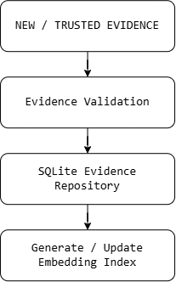

During verification:
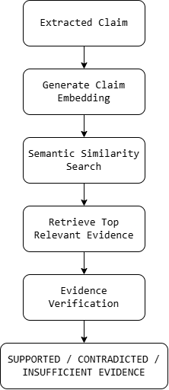

6. Decision Logic
The labels Supported, Contradicted, and Insufficient Evidence come from comparing the claim with retrieved evidence. They are not produced by directly comparing the ML classifier with the retrieval engine. The final decision layer then interprets the ML prediction together with the evidence-verification result.
ML Prediction | Evidence Result | Suggested Presentation
Reliable | Supported | Supported / strong agreement
Misinformation | Contradicted | Likely misinformation / strong agreement
Reliable | Contradicted | Conflicting assessment
Misinformation | Supported | Conflicting assessment
Either prediction | Insufficient | Insufficient evidence / requires caution
A conflict should be shown transparently instead of forcing a real/fake label. For example, if the classifier predicts Reliable but available evidence contradicts the claim, the interface may display “Conflicting Assessment” and prioritize presentation of the retrieved evidence for user review.

7. Adaptive Learning
Adaptivity should be controlled rather than allowing the model to learn immediately from every user response. User feedback can be stored in SQLite, reviewed, and converted into validated training examples. The classifier can then be periodically retrained or fine-tuned and compared against the currently deployed model.

SQLite Feedback / Adaptivity Repository
Suggested Field | Purpose
feedback_id | Unique feedback record
claim_text | Claim evaluated by the system
model_prediction | Prediction at the time of feedback
model_confidence | Recorded model score
evidence_result | Supported / Contradicted / Insufficient
user_feedback | Agree / Disagree / Flag
review_status | Pending / Validated / Rejected
validated_label | Reviewer-approved training label
model_version | Model that generated the prediction
created_at | Audit timestamp
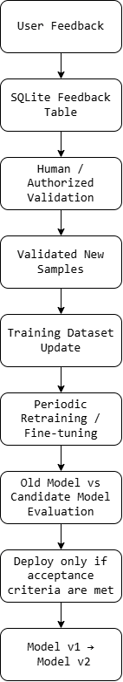

Optional active-learning logic can prioritize uncertain or conflicting cases for review. For example, low-confidence predictions or cases where the ML classifier and evidence verification disagree may be reviewed before high-confidence, high-agreement cases.

8. Evidence-Base Adaptivity
The evidence repository can evolve independently from the classifier. Newly collected health evidence should be validated before insertion. Once accepted, its searchable representation is generated or updated, making the new information available to future claims without necessarily retraining the misinformation classifier.

9. Suggested Technology Stack
Component | Suggested Technology
Browser Interface | Chrome Extension (Manifest V3), HTML/CSS/JavaScript or TypeScript
Backend API | Python + FastAPI
ML/NLP | scikit-learn; Transformers/PyTorch as needed
Semantic Embeddings | Sentence-transformer or equivalent embedding model
Evidence & Feedback Storage | SQLite for prototype
Model Artifacts | Versioned serialized model/checkpoint files
Administration/Validation | Simple reviewer interface or protected backend workflow

10. Scope and Important Rules
- Only health-related, verifiable claims proceed to misinformation verification.
- A factual/verifiable claim does not mean the claim is true; it means the statement can be checked against evidence.
- No relevant evidence should result in Insufficient Evidence, not automatically Fake.
- Source credibility may be used as a signal, but a trusted source should not automatically make every statement true.
- User feedback must not directly retrain the production model without validation.
- Model confidence should not be presented as absolute factual certainty.
- Evidence sources and dates should be retained so results remain traceable and auditable.
- The final novelty claim must be supported by the review of related literature and existing systems.

11. Proposed Research Contribution / Novelty Direction
The proposed contribution should not be framed simply as “a Chrome extension” or “the use of multiple ML models.” A stronger direction is the integration and evaluation of claim-level health misinformation detection, hybrid machine-learning classification, semantic evidence retrieval, evidence-aware verification, explainable disagreement handling, and controlled feedback-assisted model improvement directly within the browsing experience.
A possible research question is: “Can an evidence-aware verification layer improve the reliability and usefulness of machine-learning-based health misinformation detection compared with classification alone?”

12. Recommended Prototype Priority
For an early prototype, prioritize the end-to-end path: Chrome extension → claim extraction/detection → FastAPI → ML prediction → SQLite evidence retrieval → evidence verification → explainable result. Feedback collection can be implemented early, while automated retraining should be introduced only after the validation and model-versioning workflow is stable.
13. Complete Model Training Architecture
This section defines the complete offline training pipeline for the misinformation classifier. Training is separate from the live Chrome-extension inference flow. The output of this pipeline is a validated, versioned model artifact that the FastAPI backend loads for predictions.
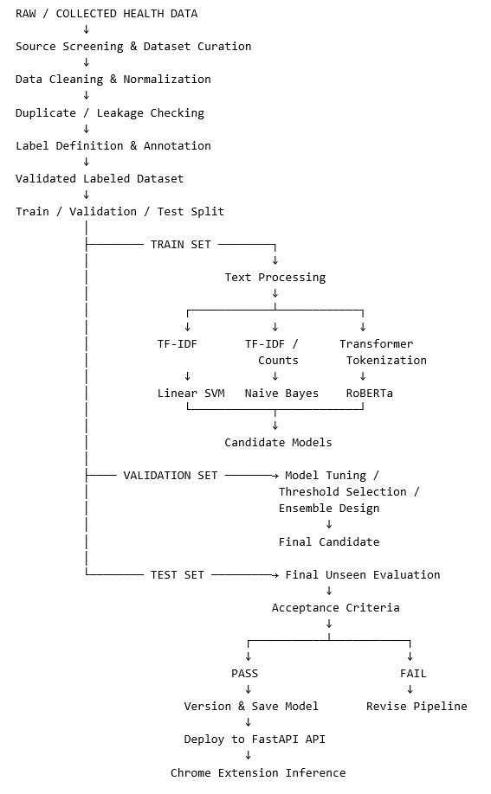

13.1 Dataset Collection and Curation
The training corpus should contain health-related textual claims or content with clearly defined target labels. Data may come from suitable public research datasets and/or manually curated sources, subject to licensing and research requirements. The dataset used to train the classifier must be documented separately from the evidence repository used during live verification.
- Define the target domain: health misinformation only.
- Define exactly what one training sample represents: claim, sentence, post, or article excerpt.
- Remove unusable records, obvious duplicates, corrupted text, and records without defensible labels.
- Record provenance where possible so the research team can trace where training samples came from.
- Check class distribution before training to identify imbalance.

13.2 Labeling Structure
For the classifier, a simple initial target may be Reliable versus Misinformation if this matches the chosen dataset and research objective. These classifier labels are different from the evidence-verification labels Supported, Contradicted, and Insufficient Evidence.
If manual annotation is required, the team should create written labeling guidelines and use reviewer agreement or adjudication for ambiguous samples rather than labeling by intuition alone.

13.3 Train / Validation / Test Split
The dataset should be divided before final model development. The training set is used to learn model parameters; the validation set is used for model selection, hyperparameter tuning, threshold selection, and ensemble design; the test set remains unseen until final evaluation.
A stratified split such as 70/15/15 or 80/10/10 can be considered depending on dataset size. The exact ratio is less important than preventing data leakage. Near-duplicate claims, reposts, or records derived from the same source item should not be distributed across training and test sets in a way that makes the evaluation artificially easy.

13.4 Preprocessing and Model-Specific Inputs
Preprocessing should be model-specific. Traditional models can use normalized text and TF-IDF/count-based features. Transformer models should normally retain natural sentence structure and use the tokenizer required by the selected pretrained model. Excessive cleaning can remove useful context such as negation.

13.5 Candidate Model Training
The existing three-model concept can be retained as an experimental architecture. Each model is trained and evaluated independently before any ensemble is created.
Candidate | Typical Input | Role
Linear SVM | TF-IDF vectors | Strong traditional text-classification baseline
Naive Bayes | Word/count or TF-IDF-derived features | Simple probabilistic baseline
RoBERTa / Transformer | Tokenized contextual text | Context-aware neural classifier

13.6 Validation, Tuning, and Ensemble Construction
Validation results determine which models are retained. Hyperparameters, decision thresholds, and any ensemble weights should be chosen from validation performance rather than manually assigned without evidence. If an ensemble does not outperform the strongest single model or does not provide another measurable benefit, the team should not assume that using more models is automatically better.
Possible ensemble methods include majority voting, probability/score aggregation where scores are comparable and properly calibrated, or validation-derived weighted voting. The selected method must be documented and reproducible.

13.7 Evaluation and Acceptance Gate
The final candidate is evaluated on the held-out test set. Recommended metrics include Accuracy, Precision, Recall, F1-score, confusion matrix, and per-class metrics. Because misinformation detection may involve class imbalance, macro-F1 and class-specific recall should be considered alongside overall accuracy.
Deployment should occur only when the candidate satisfies predefined acceptance criteria and its errors have been reviewed. The final report should include examples of false positives and false negatives, not only aggregate scores.

13.8 Model Packaging and Deployment
Approved Model
↓
Save:
• model artifact / checkpoint
• tokenizer or vectorizer
• label mapping
• threshold / ensemble configuration
• training date
• dataset version
• evaluation metrics
↓
Assign Model Version (e.g., v1.0)
↓
FastAPI loads approved version
↓
Live inference from Chrome Extension

14. Adaptive Retraining Architecture
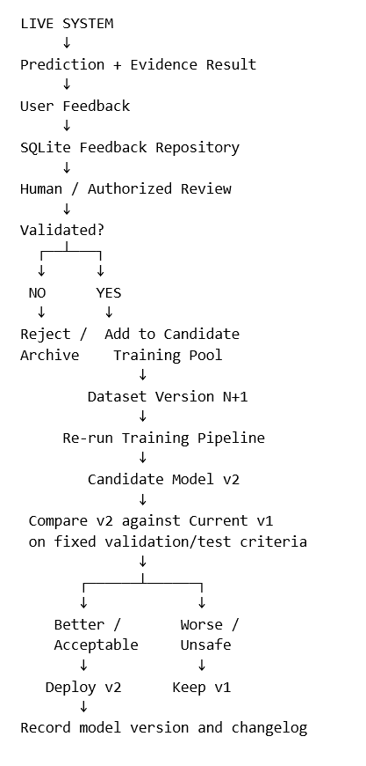
Adaptivity extends the original training pipeline rather than bypassing it. New feedback is not allowed to update the production model immediately. SQLite can store feedback and review status, while validated samples become candidate additions to the next dataset version.

14.1 Active Learning Option
To reduce review workload, the system may prioritize samples that are most informative: low-confidence predictions, ML-versus-evidence conflicts, or unfamiliar claims. These cases are reviewed first and, once validated, can be added to future training data. This provides controlled adaptation without trusting every user submission.

14.2 Recommended SQLite Separation
SQLite may support the prototype using logically separate tables for evidence, user feedback, review decisions, dataset versions, and model versions. Training files/model checkpoints should remain versioned artifacts rather than being stored as ordinary database rows.
Table / Artifact | Purpose
evidence | Validated passages and source metadata for retrieval
feedback | User agree/disagree/flag events
feedback_reviews | Human validation and approved label
dataset_versions | Which validated samples belong to each training release
model_versions | Model version, metrics, dataset version, deployment status
Model files/checkpoints | Actual trained SVM/NB/transformer/vectorizer/tokenizer artifacts

15. End-to-End Architecture Summary
A. OFFLINE TRAINING
Curated Labeled Dataset
→ Clean / Validate
→ Split
→ Train SVM + NB + Transformer
→ Validate / Tune / Build Ensemble
→ Test
→ Version Approved Model
→ Deploy API
B. LIVE VERIFICATION
Web Content
→ Detect Health + Verifiable Claim
→ Extract Claim
→ ML Prediction
+
→ SQLite Evidence Search
→ Evidence Verification
→ Decision Layer
→ Explainable Chrome Extension Result
C. ADAPTIVE LOOP
User Feedback / Difficult Cases
→ SQLite
→ Human Validation
→ Validated Training Pool
→ New Dataset Version
→ Retrain
→ Compare Model Versions
→ Controlled Deployment
D. EVIDENCE UPDATE LOOP
New Trusted Evidence
→ Evidence Validation
→ SQLite Evidence Repository
→ Update Semantic Index
→ Immediately Available for Future Retrieval
16. Web Content Extraction Strategy
The project will use two content-extraction modes. The primary implementation for the initial prototype will be user-highlighted text selection because it reduces webpage-parsing complexity, gives the user direct control over the exact statement to be verified, and is less dependent on the changing DOM structure of individual websites. Automatic webpage scanning will also be developed as an extended mode, but it requires additional extraction, segmentation, filtering, and claim-identification logic.

16.1 Primary Mode: User-Highlighted Text
In the primary mode, the user manually highlights a statement, sentence, or short passage on a webpage. The Chrome extension captures only the selected text and sends it to the backend. This avoids sending an entire webpage containing navigation labels, advertisements, comments, buttons, unrelated posts, and other non-content elements.
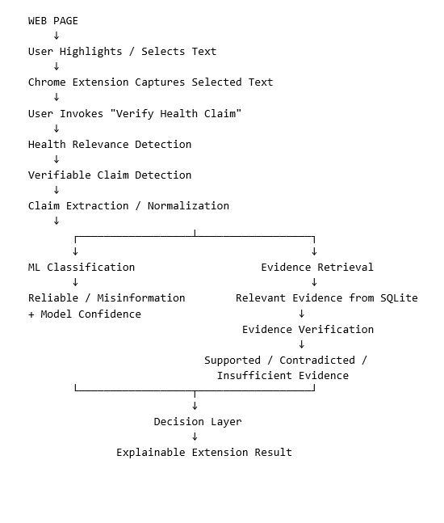

If the highlighted text is not health-related, the system should return an out-of-scope message. If it is health-related but contains no verifiable factual claim, the system should return “No Verifiable Health Claim Detected” instead of forcing a misinformation prediction.

16.2 Why Highlighted Selection Is the Initial Choice
- Lower implementation complexity because the extension does not need to understand the full structure of every supported website.
- More precise input because the user explicitly identifies the statement they want to verify.
- Better cross-site compatibility because selectable text can be captured without relying heavily on platform-specific DOM selectors.
- Reduced noise because menus, advertisements, comments, unrelated text, and other page elements are excluded from the analysis.
- Better alignment with claim-level verification because the system receives a focused passage rather than a complete page.
- Allows the team to prioritize the core research components: ML classification, evidence retrieval, evidence verification, explainability, and adaptive learning.

16.3 Extended Mode: Automatic Webpage Claim Detection
Automatic scanning remains part of the planned system. In this mode, the extension analyzes webpage content without requiring the user to manually select each statement. Because webpages contain many unrelated interface elements and may contain multiple claims, automatic mode requires a dedicated extraction pipeline before the misinformation classifier is used.
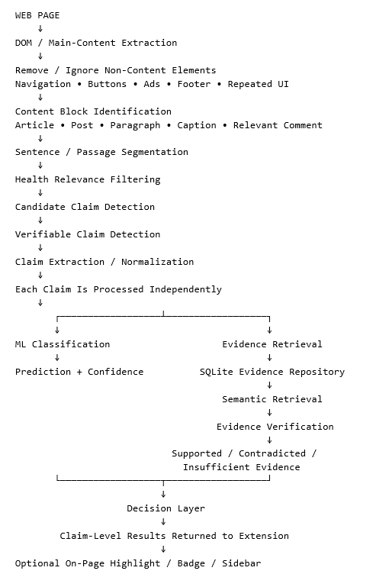

16.4 Automatic Mode: Claim-by-Claim Processing
The automatic mode must not classify an entire long article or page as one Real/Fake item. A page may contain several factual claims, opinions, questions, and unrelated statements. The system should segment the extracted content and verify individual health-related claims separately.
Example Page
↓
Sentence 1: "Exercise can improve cardiovascular health."
Sentence 2: "Drinking bleach cures COVID-19."
Sentence 3: "I think this article is frightening."
↓
Health + Claim Filtering
↓
Claim 1 → Verify Independently
Claim 2 → Verify Independently
Sentence 3 → Opinion; No Verification
↓
Return separate claim-level assessments

16.5 Recommended Development Order
The highlighted-text workflow should be completed and evaluated first. Automatic scanning should then reuse the same downstream verification pipeline; only the content-acquisition stage changes. This avoids building two separate misinformation systems.
PHASE 1 - PRIMARY / LOWER COMPLEXITY
User Highlight
→ Claim Validation
→ ML + Evidence Verification
→ Result
PHASE 2 - AUTOMATIC EXTRACTION
Whole Webpage
→ Content Extraction
→ Segmentation
→ Health Filter
→ Claim Detection
→ Send Each Valid Claim to the SAME
ML + Evidence Verification Pipeline
→ Automatic Claim-Level Results

16.6 Scope Statement for Documentation / Defense
The system prioritizes user-selected text as the primary claim-acquisition mechanism to reduce webpage extraction complexity and provide precise claim-level input across different websites. An automatic scanning mode is also planned, in which webpage content is extracted, segmented, filtered for health relevance, and screened for verifiable claims before each detected claim is passed to the same misinformation classification and evidence verification pipeline.

17. Language Scope and Technology Selection
This section was added after the original architecture was agreed. It states the language scope, the proposed technologies for each pipeline stage, and the hardware limits for model training. Items marked OPEN require a decision or an experiment before they are final. The full working version is maintained in TECH_STACK.md.

17.1 Language Scope
The system handles English and Tagalog content, including mixed Tagalog-English (Taglish) text commonly found on social media. The primary approach is to use multilingual models so that Tagalog is processed directly, without a translation step.

17.2 Optional Translation Stage
A translation stage (Tagalog/Taglish to English) may be placed before health-domain detection. It is not the default, because machine translation can reverse negation and distort culturally specific health terms, and it introduces a second source of error that makes classifier errors harder to attribute. If used, the original text is always retained and shown to the user. Its value is to be tested by comparing accuracy on a manually labeled Tagalog test set with and without translation.
Selected text → language tag → [optional: translate to English] → health-domain detection → verifiable-claim detection → claim extraction → ML classification and evidence retrieval → evidence verification → decision layer.

17.3 Proposed Technology by Stage
Stage | Proposed technology | Status
Browser interface | Chrome Extension (Manifest V3), JavaScript/TypeScript | Agreed (section 9)
Backend API | Python, FastAPI, uvicorn, pydantic | Agreed (section 9)
Storage | SQLite | Agreed (sections 5, 14.2)
Language tagging | Function-word heuristic; fastText language ID or langdetect as replacement | OPEN
Health-domain and verifiable-claim detection | Health lexicon plus a small classifier | OPEN
Traditional classifiers | Linear SVM and Multinomial Naive Bayes on TF-IDF features (scikit-learn) | Matches section 13.5
Transformer classifier | xlm-roberta-base (multilingual RoBERTa), Hugging Face Transformers, PyTorch | Refines section 13.5
Semantic embeddings | sentence-transformers: paraphrase-multilingual-MiniLM-L12-v2 (alternative: LaBSE) | Matches section 9
Vector search | Cosine similarity over a NumPy matrix; FAISS only if the evidence base grows large | Proposed
Evidence verification | Multilingual NLI cross-encoder (candidate: an mDeBERTa-v3 XNLI model) mapped to Supported / Contradicted / Insufficient Evidence | OPEN; method not specified in section 5
Translation (optional) | NLLB-200 distilled (about 600M parameters), license CC-BY-NC | OPEN; experiment only
Evaluation | Accuracy, precision, recall, F1, macro-F1, confusion matrix, per-class recall (scikit-learn) | Matches section 13.7
Model artifacts | One folder per version with model, tokenizer/vectorizer, label map, thresholds, dataset version, metrics; registered in model_versions | Matches section 13.8

Model licenses must be verified on each model card before being cited. The NLLB license is non-commercial.

17.4 Hardware Constraints and Training Configuration
Training and inference run on a laptop with an NVIDIA GeForce RTX 2050 (4 GB VRAM). This permits SVM and Naive Bayes training on CPU, embedding generation, and xlm-roberta-base inference. Fine-tuning xlm-roberta-base is possible but tight and requires mixed precision (fp16), a small batch size (about 8), a maximum sequence length of about 128 tokens, and gradient accumulation. Larger models (xlm-roberta-large, large translation models, large language models) are outside the hardware budget.
All training runs must be reproducible: fixed random seeds, pinned library versions, and the configuration saved with each model version.

17.5 Open Decisions
- Whether the translation stage is implemented as part of the system or used only as an ablation experiment.
- The NLI verifier model and its acceptance threshold; no relevant evidence or low confidence must return Insufficient Evidence.
- The method for health-domain and verifiable-claim detection.
- The language-identification method beyond the current heuristic.
- A sufficiently large labeled dataset; the current seed set is too small and too imbalanced to train or evaluate the planned models.

